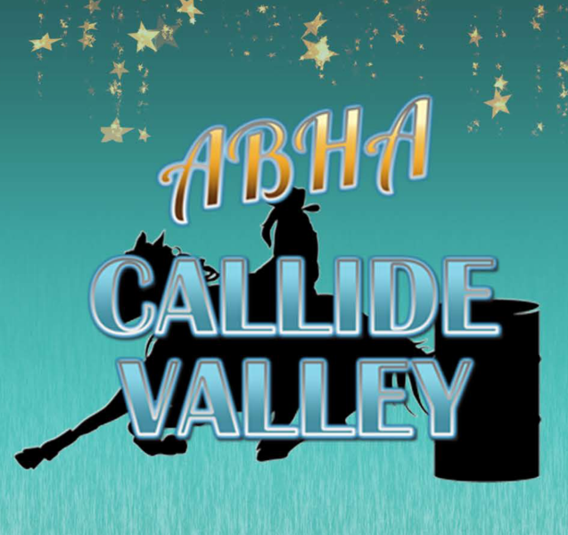

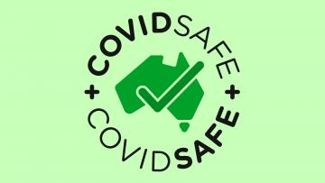
SAFETY PLAN

General Information

What is COVID-19

Coronaviruses are a large family of viruses that cause respiratory infections. These can range from the common cold to more serious diseases. COVID-19 is a disease caused by a new form of coronavirus. It was first reported in December 2019 in Wuhan City in China.

Symptoms

Symptoms of COVID-19 can range from mild illness to pneumonia. Some people will recover easily, and others may get very sick very quickly.
People with coronavirus may experience:
- fever
- symptoms such as coughing, a sore throat and fatigue
- shortness of breath
If you are concerned you may have COVID-19:
- use the symptom checker
- see how to seek medical attention
- see more about testing
healthdirect Coronavirus (COVID-19) Symptom Checker
Answer questions about your symptoms to see if you need to seek medical help or get tested. This tool is available online at any time.
If you do not have any symptoms, you should still protect yourself and others.

How it spreads

The virus can spread from person to person through:
- close contact with an infectious person (including in the 48 hours before they had symptoms)
- contact with droplets from an infected person’s cough or sneeze
- touching objects or surfaces (like doorknobs or tables) that have droplets from an infected person, and then touching your mouth or face
COVID-19 is a new disease, so there is no existing immunity in our community. This means that COVID-19 could spread widely and quickly.

Protect yourself and others

Everyone must do the following things to slow the spread of COVID-19 and protect those who are most at risk.
See important advice on:
- good hygiene
- social distancing
- public gatherings
- self-isolation

How to seek medical attention

If you are sick and think you have symptoms of COVID-19, seek medical advice. If you want to talk to someone about your symptoms, call the National Coronavirus Helpline for advice.

National Coronavirus Helpline
Call this line if you are seeking information on coronavirus. The line operates 24 hours a day, seven days a week.
1800 020 080
To seek medical help from a doctor or hospital, call ahead of time to book an appointment.

What’s new for ABHA Affiliates?
Affiliates are in a position now to set dates but there will be a new approval process and may vary from state to state. Please note - if restrictions are put back in place events will be suspended.

Advice from Federal Government
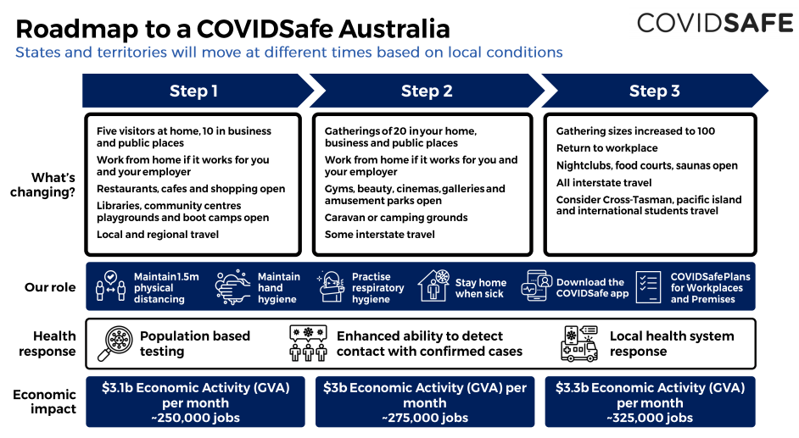
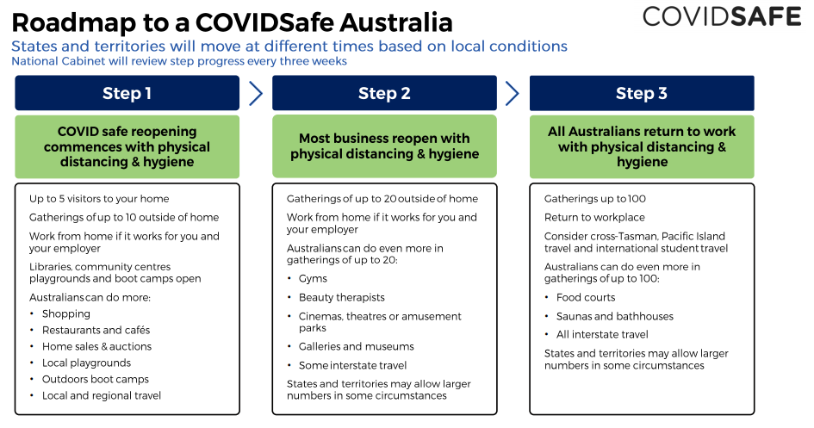
Australia - https://www.australia.gov.au/
New South Wales - https://www.nsw.gov.au/news/nsw-to-ease-covid-19-restrictions-from-friday-15-may
Queensland - https://www.covid19.qld.gov.au/government-actions/roadmap-to-easing-queenslands-restrictions
Victoria - https://www.dhhs.vic.gov.au/gradual-easing-restrictions-covid-19
Tasmania - https://www.coronavirus.tas.gov.au/facts/important-community-updates
Northern Territory - https://coronavirus.nt.gov.au/
South Australia - https://www.covid-19.sa.gov.au/recovery
Western Australia - https://www.wa.gov.au/organisation/department-of-the-premier-and-cabinet/covid-19-coronavirus-latest-updates

Advise – AIS (Australian Institute of Sport)
The Australian Institute of Sport (AIS) and Sport Australia welcome the update on Friday 8th May from National Cabinet on the three-step plan to ease the current restrictions in place as a result of COVID-19.
The release of the three-step plan is a positive step towards the reintroduction of sport and recreation, which links to the AIS Framework for Rebooting Sport in a COVID-19 Environment and we know will be welcomed by many Australians.
It is important to reiterate that all sport and recreation resumption decisions must be based on State and Territory COVID-19 public health advice. Links to those relevant authorities are listed below. Sports and athletes should follow the public health regulations issued by their local jurisdiction.
The AIS team, led by Chief Medical Officer, Dr David Hughes, developed the AIS Reboot Framework in collaboration with sport CMOs around Australia and in consultation with the Federal Government’s CMOs. The Framework underpins the National Principles for the Resumption of Sport and Recreation Activities, and has been adopted by the Australian Health Protection Principal Committee (AHPPC) and National Cabinet as the guide for the reintroduction of sport and recreation.
We will continue to work with sport to assist in implementing a safer return to training and competition activities in alignment with State and Territory advice and encourage everyone to download the COVID Safe app.

ABHA CALLIDE VALLEY will be implementing the following rules & regulations to comply with being a COVID -19 safe environment.
Physical distancing
- A minimum space of 1.5 metres between you and other people that aren’t from your household.
- If you need to be facing another person and closer than 1.5 metres apart minimise contact to less than 15 minutes.
- A minimum space of 4 m2 per person when indoors including indoor arenas.

Practice Good Hygiene
- Avoid touching your face and cough and sneeze into a tissue or into your elbow.
- Hand washing with soap and water for 20 seconds or use hand sanitiser before and after any contact with surfaces that is used by more than one person. Hand soap and sanitiser is provided in the toilets.
- Avoid sharing cups, utensils and cigarettes.
Compliance
- If found non-compliant you will be asked to leave the grounds
- If you are feeling unwell, please do not attend the event
- Any serious breaches will be reported & if necessary actions will be taken, this may include forfeiture of the days event nominations or prize money and further disqualification to our club events if necessary.
General
- There is to be no sharing or cross contamination of any equipment (e.g. whips, helmets etc.)
- There is to be no hand shaking or high fives.
- We encourage you supply your own drinking bottles and water
- Limiting of cash transactions – New members are asked to pay ABHA memberships online before nominating for our event. All nominations will need to be paid by direct deposit and nominated via the face book messenger or text message. ABHA Callide Valley memberships also to be paid via direct deposit into nominated bank account.
- The handling of Money (payouts) will be one person only. This person to be nominated and must be the same person for the duration of the event.
- Our Saturday afternoon events will be run in 2 time slots, a 2pm – 4pm and a 6pm on. Competitors will allocate which time slot they wish to nominate their run. This will allow people to spread out in this time. Also allowing a break from completion of section 1 until start of section 2 to allow for any cleaning and sanitising of areas and equipment.
- Draws will be completed and posted to the face book page Friday night for the Saturday rounds and Sunday rounds. Ensure you copy the draws and know when your exhibition and competition runs will be.
- Place getters will be announced Saturday night and Sunday after completion of each of the Junior events then the open events and only the place getters will be asked to que allowing 1.5m distancing apart at the secretary table. Results will not be posted at the secretary’s table, they will be available only on the face book page when time allows after completion of the days events.
- Follow all the latest instructions and updated guidelines provided by the government particularly state and local authorities.
- The ABHA strongly recommends that all attendees download the COVID-19 Safe App.
- Appoint a COVID-19 Event Manager whose sole responsibility is to make sure all regulations and guidelines are in place at your event.
- Our club will provide Hand Washing Facilities including clean running water, liquid soap, and paper towels. If hand washing facilities are not readily available, an appropriate hand sanitiser will be provided.
- Essential attendance only – Competitors and their immediate support crew only. To adhere to the 100 persons allowed to attend, this figure includes volunteers, canteen staff and competitors. We will only accept the first 90 rider nominations, including juniors and opens (number of horses not limited). As we have 2 time slots running this will determine how many people we will have at each section.
- Ensure all personal are aware of the Venue/Arena COVID-19 procedures and are compliant.
- Entry/Exit Gate must be manned.
- “Closed Event for ABHA participants ONLY” must be posted at Entry Gate.
- Do not allow competitors to socialise – “Compete and Go Home”
- Check with your local council or shire about conditions of restarting your activity
- Check the condition of equipment and facilities at your venue to see if they are fully functional after being in lock down
- Review the scheduling of your programme and warm up areas and amend to minimise contact between groups
- Ensure all volunteers ,ground /equipment and administration personal have been briefed on the COVID 19 restrictions and there responsibility at your event
- Place signs at the entry points to instruct participants and visitors not to enter the venue if they are unwell or have COVID 19 symptoms .The sign should state that your organisation has the right to refuse entry and must insist that anyone with symptoms leave the venue.
- Implement measures to restrict numbers at the venue so you don’t exceed regulations.
- Make arrangements for the recording of all people in attendance e.g. Name, contact details or membership no and send to ABHA office to be held for 28 days. A sign at entry gate will instruct everyone attending to complete registration form at secretary’s table.
- Ensure physical distancing by placing ground or wall markings or signs to identify 1.5 metre distance between persons for queues and waiting areas e.g. each competitor, payouts, toilets ,food areas
- Remove seating or space seating at least 1.5 metres apart. Mark rails or ground to encourage appropriate distancing and BYO seating.
- Put signs and posters up to remind people of the risk of COVID19
- Consider the requirements of vulnerable groups i.e. (people with disabilities, indigenous and elderly people]
- Know the protocols for notifying health authorities of issues or suspected COVID 19 cases.
- Establish sports medicine /first aid protocols that limit exposure(refer to Sports Medicine Australia SMA Support during COVID-19)
- Implement cleaning protocols and keep a record of cleaning regime. This includes cleaning and disinfecting every surface at completion of event.
- Clean frequently touched areas and surfaces at least hourly with detergent or disinfectant.(including shared equipment and tools ,tables, counter tops and sinks)Surfaces used by competitors ,judges, time keepers must be cleaned between users.
- Consult with event organisers and volunteers on COVID 19 measures and provide adequate information and education including changes to tasks and practices for the running of the event including cleaning and disinfection practises.
- We will complete and display the COVID 19 Safe Check for dinning if you are having a canteen or promote BYO food. There will be no seating available at the canteen table for customers as it will be all take away food.
- Regularly review our systems of operation to ensure they are consistent with current directions and advice provided by health authorities.

