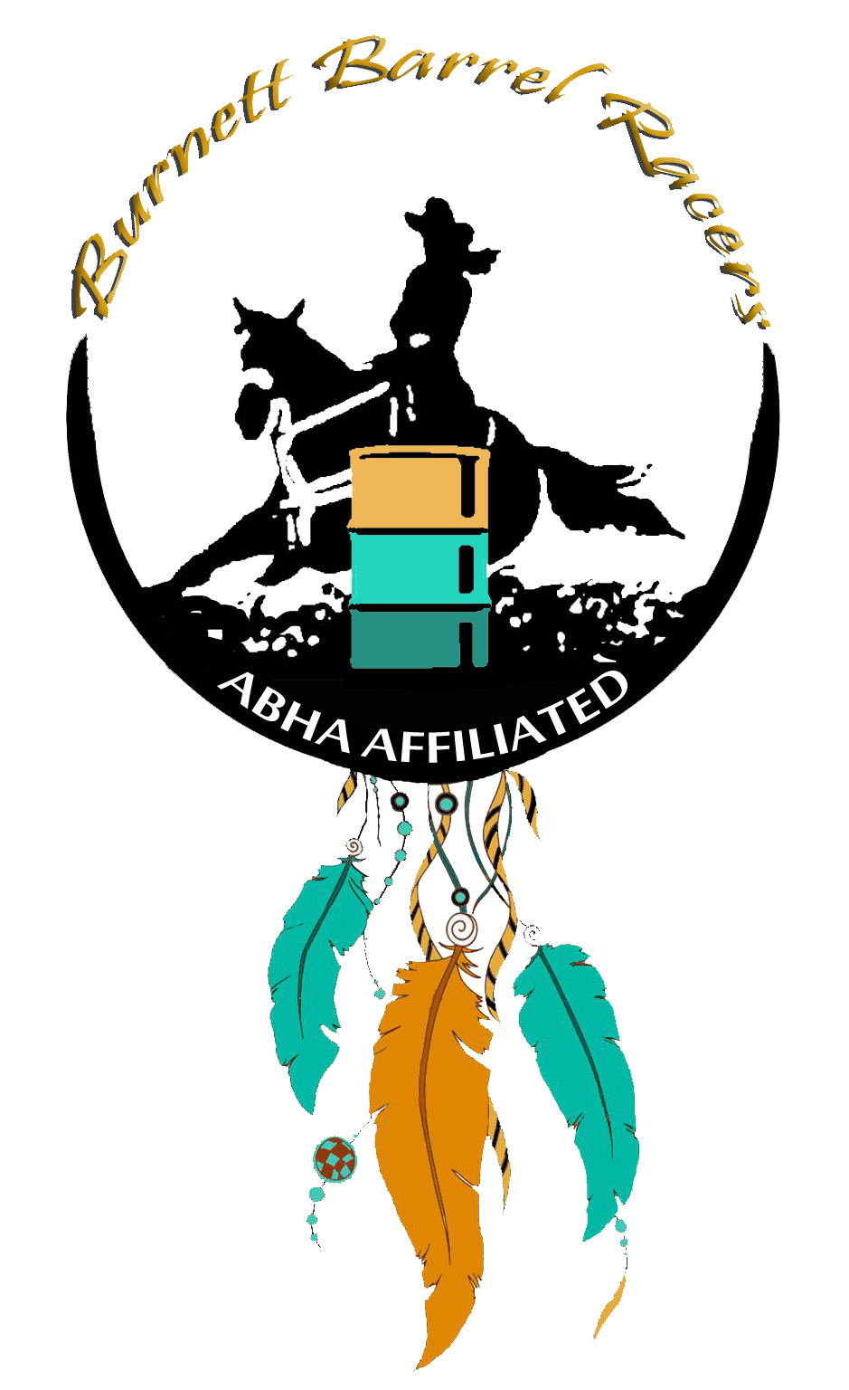

ARENA HIRE- $5 PER PERSON

EXHIBITION RUN- $5 PER RUN

LEDS- $5 PER RUN

PEE WEE- $10 PER RUN

OPEN 4D- $30 PER RUN ***EXHIBITIONS START 9AM***

JUNIOR 4D- $20 PER RUN ***EVENT START 10AM***

JUNIOR POLES- $10 PER RUN

OPEN POLES- $15 PER RUN

FUTURITY SIDE POT- $15 (horse 4/5/6 yrs)

MATURITY SIDE POT- $15 (horse7/8/9 yrs)

SENIOR HORSE SIDE POT- $15 (horse 15yrs and over)

***FUTURITY/MATURITY/SENIOR horse side pot time will be taken from the horses first run of the event***. No payout for the event all proceeds will go to end of year prizes. Proof of age forms or horse registration papers must be provided with nominations. Forms can be found on ABHA website and must be filled by a Vet.

***ABHA RULES CAN BE FOUND AT abha.com.au BURNETTE BARREL RACERS RULES CAN BE FOUND ON OUR FACEBOOK PAGE.***

**Monto Show Grounds**

**Camping is available at Monto Showgrounds, Power, Stables and Amenities all available. Stables and electric fences must be racked and left clean. ALL RUBBISH TO BE COLLECTED AND REMOVED FROM CAMPSITES. COVID RULES APPLY.**

**Horse movement declaration form must be filled and handed to the club on arrival. PIC NUMBER IS QCMN0635**

**NOMINATIONS**

**To go into the draw nominations are open now and close on Friday the 12th November at 5pm. Payment of nominations to be paid into the Burnett Barrel Racers Inc account (above). Burnett Barrel Racers will still take nominations up until the event starting, however you will be added to the bottom of the draws and full payment must be received in cash prior to event start.**

**MEMBERSHIPS**

**ABHA MEMBERSHIP MUST BE PAID BEFORE NOMINATING. This can be done online following the links at abha.com.au**

**To be eligible for prizes at the end of the series, a once off Burnett Barrel Racers club membership fee must be paid into our club account above. Open membership is $15, juniors is $10, If you wish to compete for both Open and Junior prizes the fee will be $25. Membership forms are available on our facebook page or can be emailed upon request.**

***DATE: Finals 14th November***

**VENUE: Monto Show Grounds**

**NOMINATIONS TO: Burnett Barrel Racer’s facebook page through messages**

**PAYMENT TO: Burnett Barrel Racers Inc, bsb 124-960, account 23151299**

*BURNETT BARREL RACER’S 2021 SERIES*