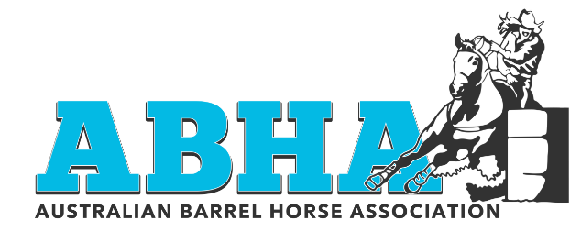
ABHA MERCHANDISE ORDER FORM
Australian Barrel Horse Association
C/ Suzie Dicks
PO Box 631
Cootamundra
NSW 2590
Email – suzz1976@hotmail.com
Customer Details |  | ORDER DATE | ORDER NO.
Name -
Address -
Phone -
Email Address -
DESCRIPTION | QTY | UNIT PRICE | TOTAL
ABHA Wall Calender |  | $25.00
ABHA Cap |  | $20.00
ABHA Stubbie Holder |  | $10.00
Affiliate’s Only Special 10 * Caps |  | $170.00
Affiliate’s Only Special 10 * Stubbie Holders |  | $80.00
 |  | TOTAL
POSTAGE COSTS |  |  | TOTAL
1 – 5kg = $9.20 – Australia Post - Pre Paid Post Satchel.
Postage on larger orders will need to be calculated and advised
REMARKS / DELIVERY / PAYMENT INFO |  | TOTAL
Please email your order form to – suzz1976@hotmail.com

Payment Information - Account Details
NAB
Account Name : Miss Suzanne Dicks
 |  | TOTAL DUE
BSB : 082 536
Account Number : 166644682

Please Note : Orders will not be placed until payment is received.

