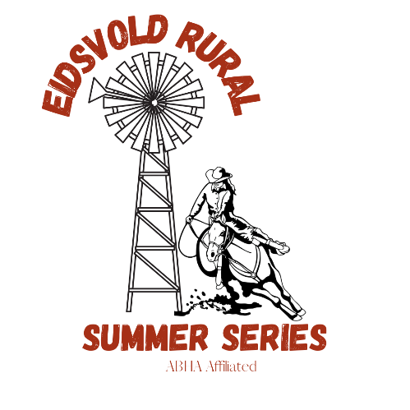
THE EIDSVOLD RURAL SUMMER SERIES
ROUND 1 & 2 : 11TH & 12TH DECEMBER 2021

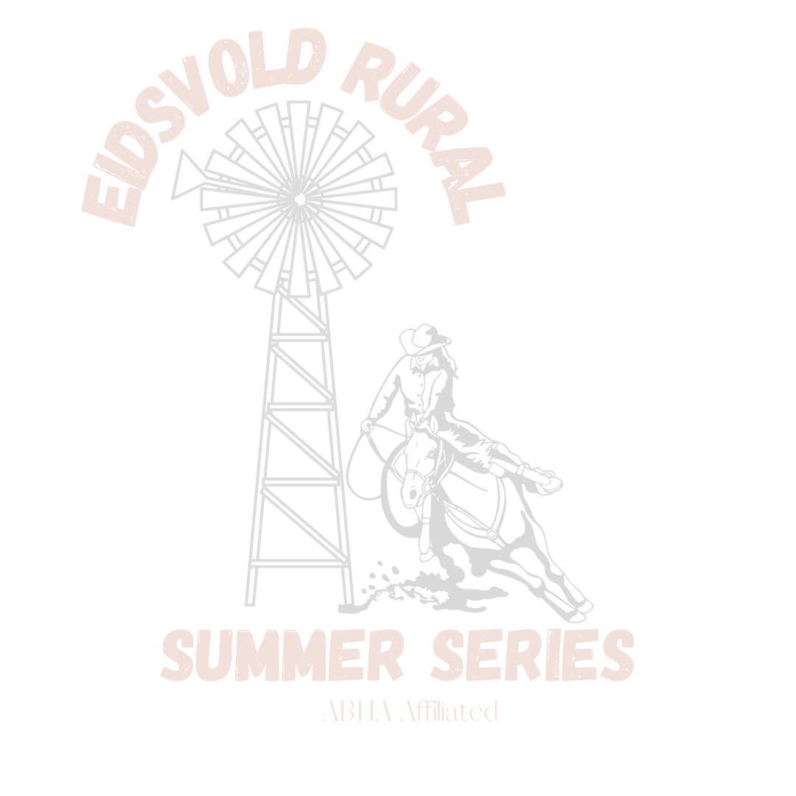
VENUE: Eidsvold Showgrounds
NOMINATIONS TO: Eidsvold Rural Summer Series facebook page through messages
PAYMENT: Cash on the day ONLY (Small notes greatly appreciated)
MEMBERSHIPS
ABHA MEMBERSHIP MUST BE PAID BEFORE NOMINATING. This can be done online following the links at abha.com.au
To be eligible for prizes at the end of the series, a once off Eidsvold Rural Summer Series club membership fee must be paid into our club account above. Open membership is $15, juniors is $10, If you wish to compete for both Open and Junior prizes the fee will be $25. Membership forms are available on our facebook page or can be emailed upon request.
NOMINATIONS
To go into the draw nominations are open now and close on Thursday the 9th of December at 5pm. Payment of nominations to be paid on the day. Eidsvold Rural Summer Series will still take nominations up until the event starting, however you will be added to the bottom of the draws and full payment must be received in cash prior to event start.
EIDSVOLD ARENA
Camping is available at Eidsvold Showgrounds, Power, Stables and Amenities all available. Stables and electric fences must be racked and left clean. ALL RUBBISH TO BE COLLECTED AND REMOVED FROM CAMPSITES. COVID RULES APPLY.
Camping fee: $10 per night
Horse movement declaration form must be filled and handed to the club on arrival. PIC NUMBER IS QBEV0218.

ARENA HIRE- $5 PER PERSON
EXHIBITION RUN- $5 PER RUN START TIMES
LEDS- $5 PER RUN SATURDAY
PEE WEE- $10 PER RUN EXHIBITIONS START 4PM
OPEN 4D- $30 PER RUN EVENT START 5PM
JUNIOR 4D- $20 PER RUN _______________
JUNIOR POLES- $10 PER RUN SUNDAY
OPEN POLES- $15 PER RUN EXHIBITIONS START 7AM
FUTURITY SIDE POT- $15 (horse 4/5/6 yrs) EVENT START 8PM
MATURITY SIDE POT- $15 (horse7/8/9 yrs)
FUTURITY & MATURITY horse side pot time will be taken from the horses first run of the event. No payout for the event all proceeds will go to end of year prizes. Proof of age forms or horse registration papers must be provided with nominations. Forms can be found on ABHA website and must be filled by a Vet.
ABHA RULES CAN BE FOUND AT abha.com.au EIDSVOLD RURAL SUMMER SERIES RULES CAN BE FOUND ON OUR FACEBOOK PAGE.

