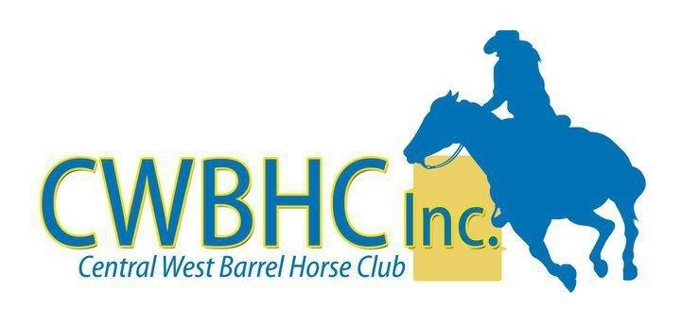
CENTRAL WEST BARREL HORSE CLUB SAFETY PLAN
SPORT OPERATIONS – LEVEL C
The Central West Barrel Horse Club will have the following plans and process
- Rahni Ryan will be the COVID-19 Safety Co-ordinator
- There will be a committee member at the gate taking down the relevant information and making sure that those who are coming through are on the list to compete.
- Upon entry to the grounds – the competitor must show that they have downloaded the COVIDsafe app – if they haven’t, they must do it on the spot.
- Upon entry they must fill out and sign our club COVID-19 Declaration.
- There will be no day entries – all entries via the internet.
- There will be no socialising and social distance must be maintained at all times.
- Warm up area will be in the Campdraft Arena.
- Entry into the Barrel Arena will be through one gate and exit will be out another gate at the other end of the arena.
- Signs will be posted on all gates, around the canteen and on all tables.
- Hand sanitiser will be placed at all gates, canteen and bathroom facilities.
- Tape will be put on the ground at the canteen to show social distancing when lining up.
- Gloves will be worn at all times while working with any food.
- There will be no time off for breaks/lunch etc so that those who compete and finish early can leave the grounds.
- Any money won will be directly deposited into their nominated bank account to save handling of physical monies.
- Constant reminding over the microphone regarding good hygiene and social distancing.
- Only one person to use the microphone for the day.
- Any spectators will be asked to stay in one area away from the competitors

